Introduction

Have you ever wanted to create your own minecraft game and run it on a public server? This class will teach you step-by-step how to do that.

We will create 3 plugins which completely describe the behavior of 3 different games:

Spleef

Bed Wars

Omaha Beach

Plugins are easier to create and more player-friendly than mods. Plugins are also installed only on the server, which makes them easier to manage.  
Typically mods are run off Forge on the client-side and the player needs to install them. The server will kick a player if it doesn't like their list of installed mods:

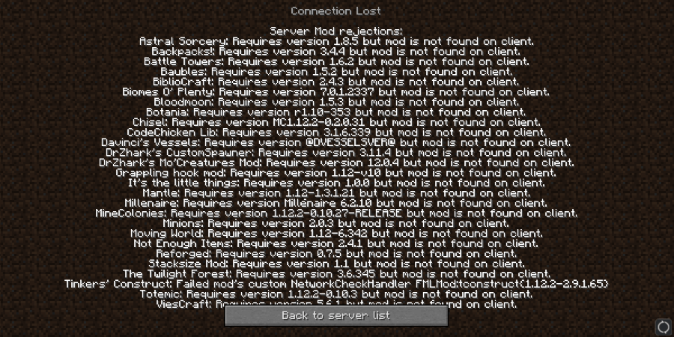  
  
Mods are also more difficult to create as they are written in java and use eclipse. The plugins we make will be created using a scratch program I wrote called **Blockly-Scriptcraft**. It looks like this:

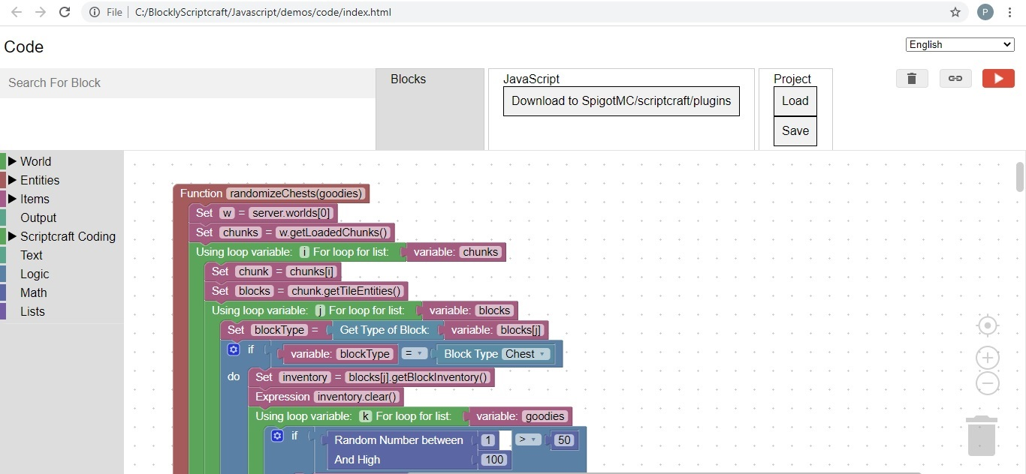

Some popular plugins you may already be aware of are: **Essentials**, **Grief Prevention**, and **World Edit**.  
This course consists of 24: 1 hour classes, 8 classes per game. We will create code in scratch and test the code on your own personal minecraft server.  
We will also discuss how to install your game on a public (paid) server, and at that end of each class you will be given access to a minecraft game on a public server that demonstrates the code we discussed in class.

Pre-Requisites

Before registering students should have:

Windows 10 computer (not MAC or iPad)

A MoJang minecraft account

A microphone and speakers (or headset) connected to their computer

64-bit git for windows installed on their personal computer from: <https://git-scm.com/download/win>

Suggested age group: 8 to 16 years old

Windows 10 Setup

Git

Download 64-Bit Git for windows: <https://git-scm.com/download/win>

Run the git install executable

Local Minecraft Server and Blockly

Open a cmd window

Hold the Windows key and press the r key  
You should see:  
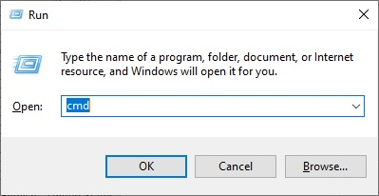

Enter the command: cmd  
You should see:  
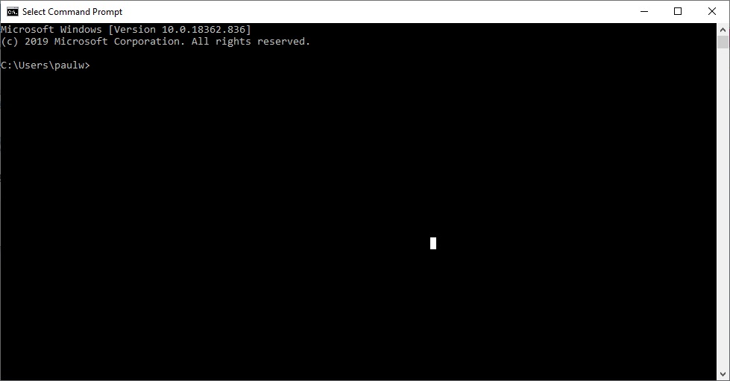

Enter the command:cd c:\

Enter the command:git clone https://www.github.com/Paulware/MinecraftServer

Enter the command:git clone https://www.github.com/Paulware/blocklyScriptcraft

Run the server by double-clicking the runServer.bat file in c:\MinecraftServer from windows explorer like:

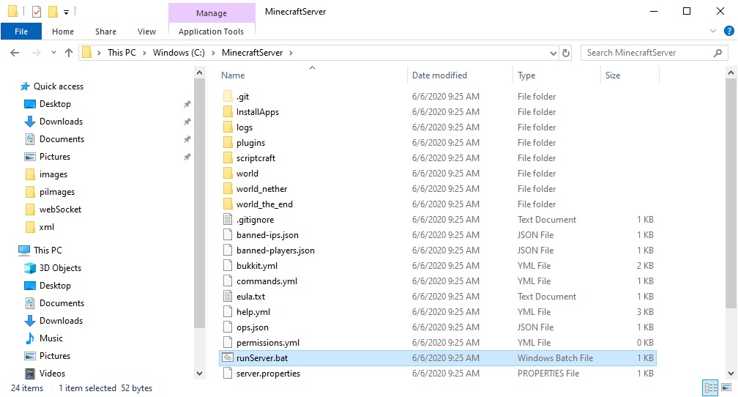

Run the scratch program by double-clicking C:\BlocklyScriptcraft\blocklyScriptcraft.html and open using google chrome like:  
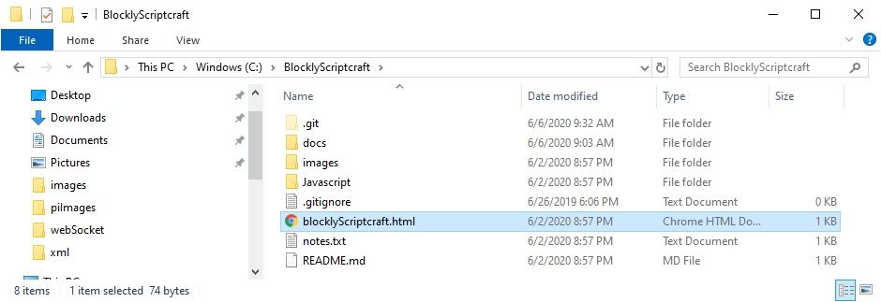

Blockly-Scriptcraft Overview

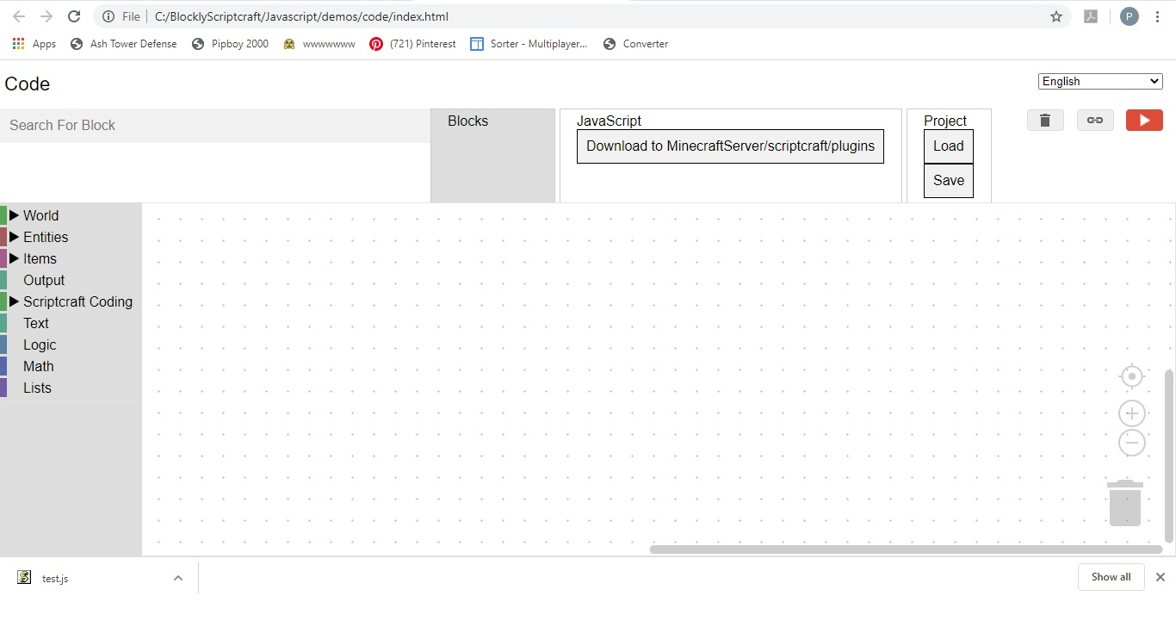**Blockly-Scriptcraft** will allow you to visually program a minecraft plugin just like you would make a scratch program  
This program should be run from the chrome browser only. To open it, double click on the blocklyScriptcraft.html file in the BlocklyScriptcraft directory on your personal computer  
On the left side is a menu that can be expanded to show sub-menus. Here you will find the blocks that you need to create your minigame

Above the menu is a Search For Block feature that will allow you find any block quickly. To try this out, type "function" into the Search for Block area. It should respond with: Function => Scriptcraft Coding, Functions. This means that the function block is found under the Scriptcraft Coding Menu, subMenu: Functions

To the right of the Search For Block feature are 3 tabs:

Blocks, which shows the current blocks being created

Javascript, which shows the javascript and allows you to download into the scriptcraft/plugins directory

Project, which allows you to save and load the current project block definitions

On the lower right is a trash can. You can drag blocks into the trash can to delete them. You can also delete or disable a block by right-clicking on the block and selecting delete or disable  
One useful feature is the duplicate block feature. You can duplicate a block, by right-clicking on the block and selecting duplicate.  
**Note:** The javascript is automatically created by Blockly-Scriptcraft. You will not need to manually edit this code.

After creating your blocks, click on the "Download to SpigotMC/scriptcraft/plugins" button, and save the file as test.js.  
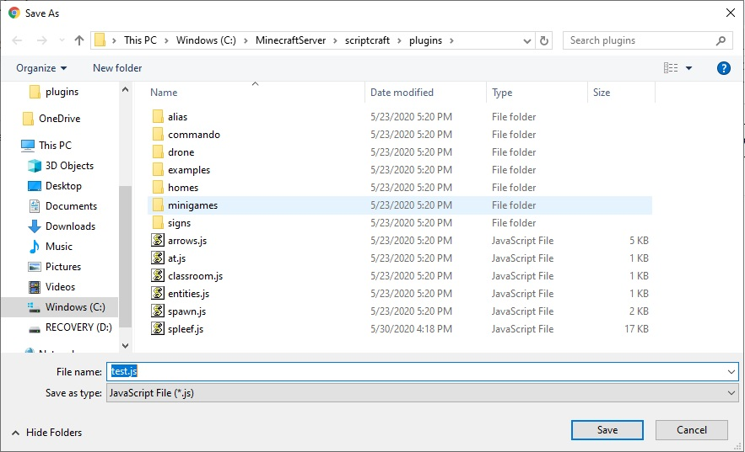  
The second time you press the "Download to SpigotMC/scriptcraft/plugins" button it will try to save to test.js(1) copy.  
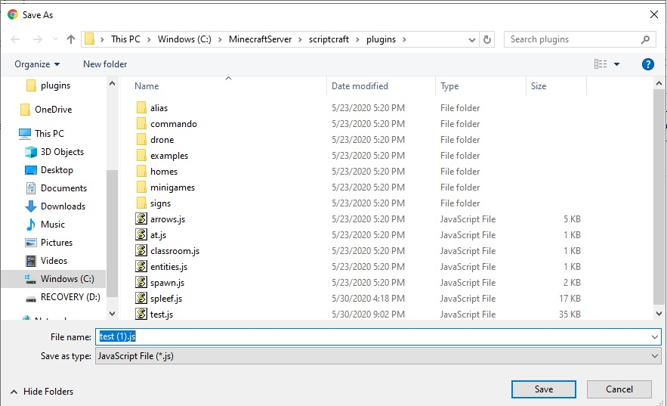  
**Do NOT use this option, it will confuse the server**, click on test.js and press ok to overwrite instead  
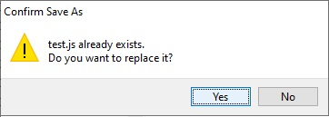  
This will place your code in an area that the minecraft server can find  
Next, in the server console window, execute the command: reload. This tells the server to read all the plugins that are available in the scriptcraft/plugins directory.  
By aware that sometimes the server will show an error when you issue the reload command. This is an indicator that there is something wrong with the blocks.  
Next run your code by issuing the server command:  
js test()  
This allows you to test the function that you have just created in blockly-scriptcraft.  
Also at this time check the server window, sometimes error appear when the test function is executed. This is another indicator that there is something wrong with the blocks.

Project 1

Spleef MiniGame

Highlights

Install your own minecraft server on your personal computer

Creating a lobby and spawn point

Select team color and prevent friendly damage

Protect certain types of blocks from destruction

Detect game winner

Reset the game world

Setup a public web server

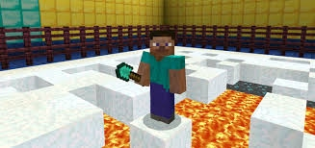  
Spleef is a classic minecraft minigame which has players battle on a fragile snow surface above a lava bed.

Special Rules

Players are only allowed to destroy snow blocks, the plugin will cancel all other block destruction

This version allows the player to select a team color, any friendly damage is cancelled

No respawn is allowed, a player that dies will become a spectator on respawn

The game is over when only one team remains

Snowball Effect

When a snowball hits a snow_block, the snow block should be deleted (changed to air)  
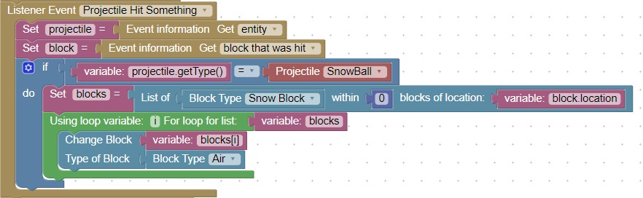  
To test this effect:

Open blockly-scriptcraft

Delete any blocks if there are some

Select a function block from Scriptcraft Coding and drag it over

Name the function block: test

Place the above code in the function block

Use Search for Block feature to find missing blocks

Download test.js to your MinecraftServer/scriptcraft/plugins directory

Run the server by executing runServer.bat located in the spigotMC directory

Open the server console and type: **reload**

Run the function with the console command: **js test()**

Open minecraft, muliplayer and connect to server: localhost

Give yourself snowballs with the server command: **give @a snowball 16**

Give yourself snowblocks with the server command: **give @a snowblock 16**

Lay some snowblocks down

Throw a snowball at the snowblock, the snowblock should disappear (turn to air)

Spleef Scoreboard

When the first person joins the server after server reset, the scoreboard is created.  
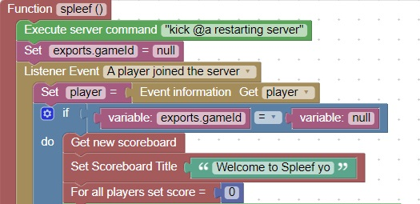

When a player dies, all other players gain a point on their scoreboard

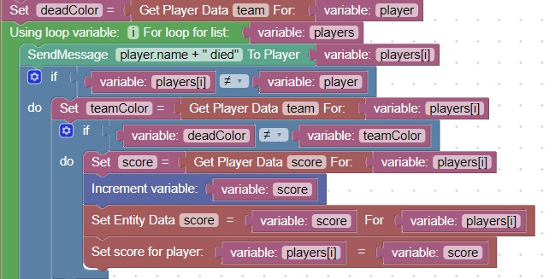

Protect All Blocks except Snow

The protect a block from destruction, use the block break event, and check the type of the block  
When the blocktype is one that you want to protect, cancel the event  
In our case, we only want to allow snow blocks to be broken, so we will use the logic:

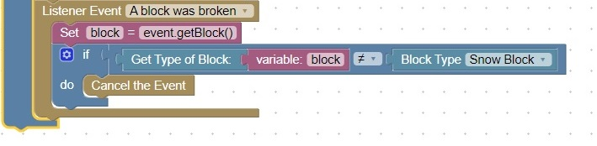  
  
**Note:**This does not protect a block from explosive damage, to do that we need to cancel the explosion based on location.

Randomize Chest Contents

When the first person joins the server, the contents of all chests should be randomized from a list:

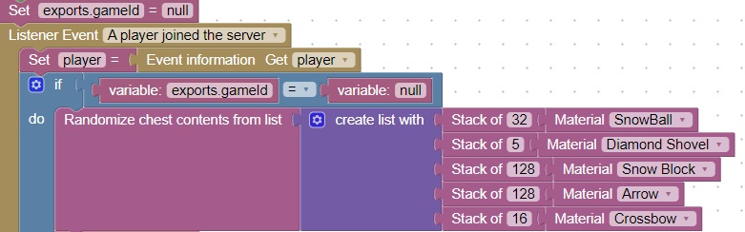

Set spawn point

There are 2 server commands that set the spawn point  
The world spawn command sets a general location  
The setspawn command sets a specific location  
When a player joins a server or respawns they are sent to the spawn point.  
This should be the location of your lobby.  
These commands should be set when the first serverJoin event is triggered after a server reload.

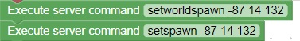

Detect if a player is joining this game for the first time

If a player disconnects and reconnects to the server, you may want to have them continue with the same settings they left with.  
This code will determine if the player has been in this same game previously.

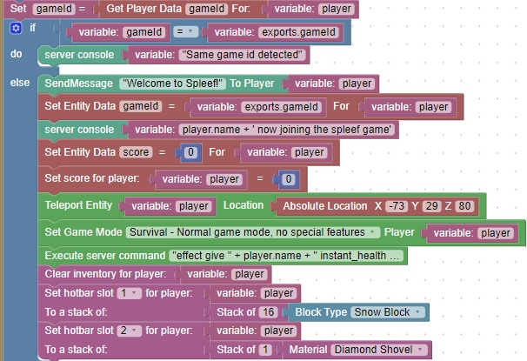

Spleef Lobby

Most of the work on a lobby is done in the minecraft world itself  
The only plugin work is to hande a click on a sign which will then assign a player to a team and teleport them to the team location  
  
This code will handle a mouse click and select a team when a team sign is clicked on

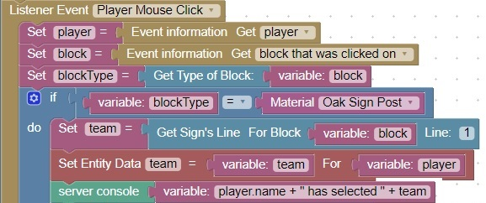

Select team color (at lobby)

When a player clicks on a sign (in the lobby), the second line of the sign indicates which team the player is selecting  
Care should be taken to avoid letting a player select a different team (than previously selected).

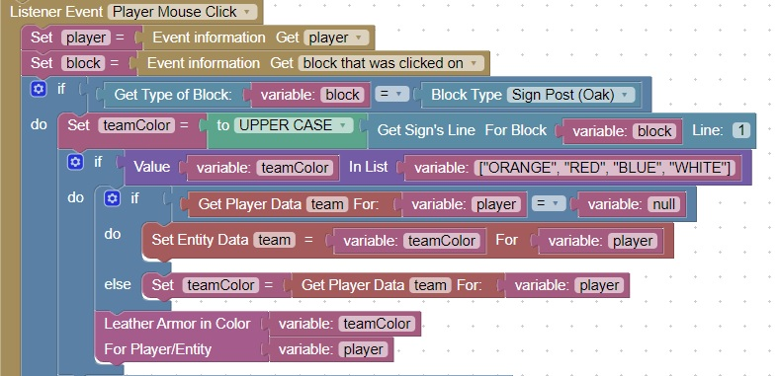

Cancel Friendly Damage

When a player damages a player on their same team, the event should be cancelled.

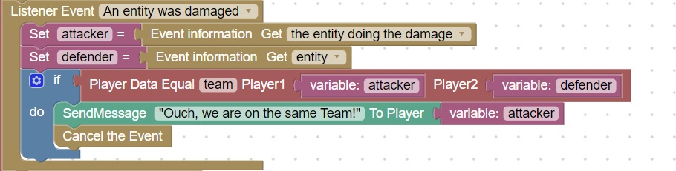

Set player location based on team

After a team is selected ( by clicking on an oak sign ), this code will teleport a player to their team spawn point

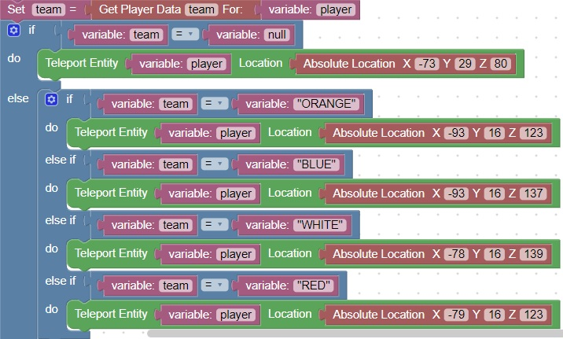

Detect Winner

When a player dies, count the number of active teams. When there is only 1 team left, that team has won.  
Kick all players and send them a message congratulating the team that won  
Also, reset gameId variable so the game will reset when the next player rejoins the server.

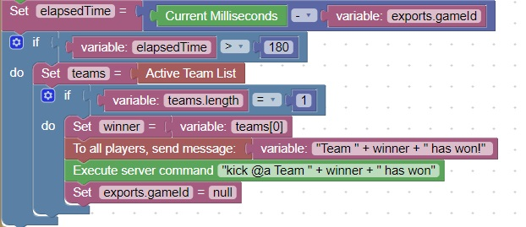

How to setup a public web-server

There are [many public minecraft servers available](https://www.google.com/search?q=minecraft+server+rent&oq=minecraft+server+rent&aqs=chrome..69i57.8933j0j8&sourceid=chrome&ie=UTF-8). Most are very similar.  
It all comes down to cost versus playability  
Here is the price chart for apexminecrafthosting.com:  
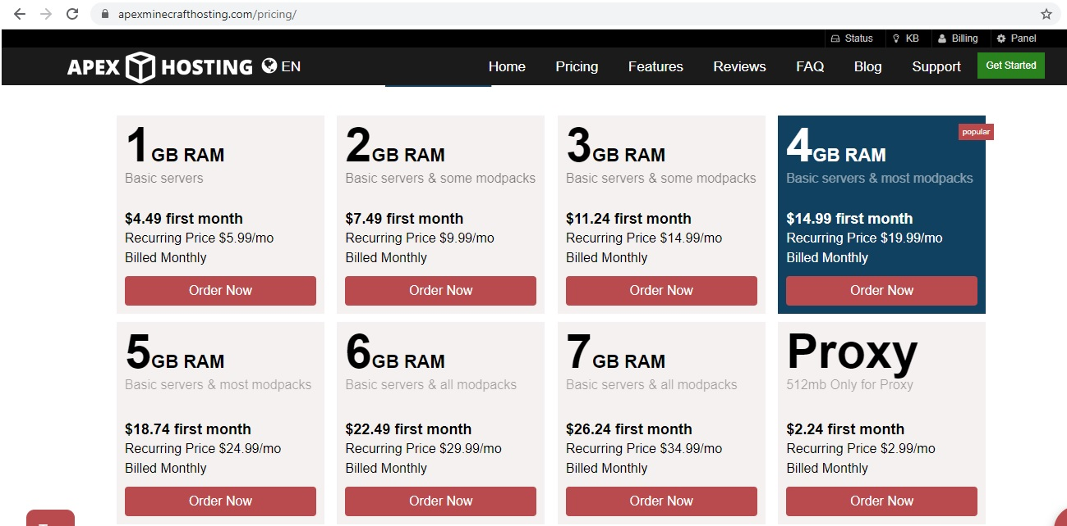  
Servers use file transfer protocol (FTP) to move files from your personal computer to the web-site:  
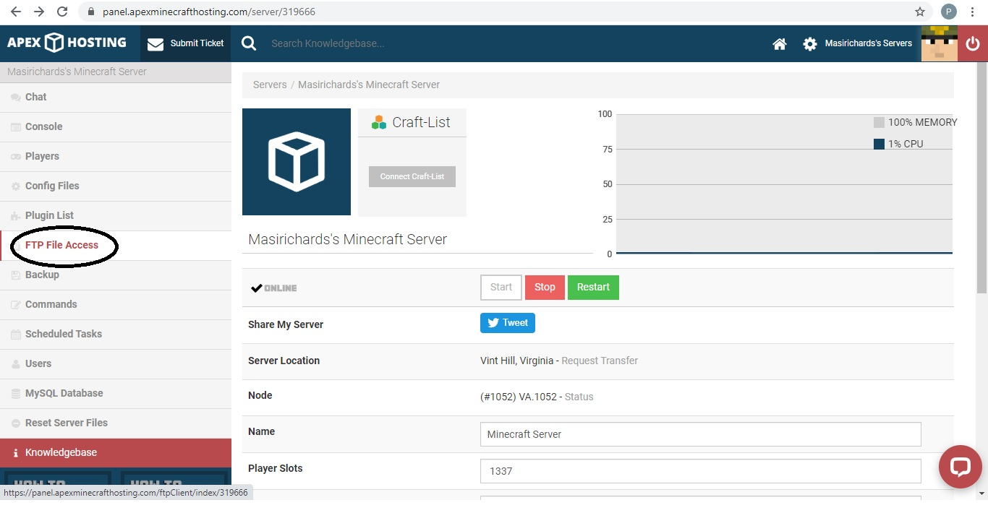

You need to copy scriptcraft.jar to the plugins directory, and copy over the files in your world directory  
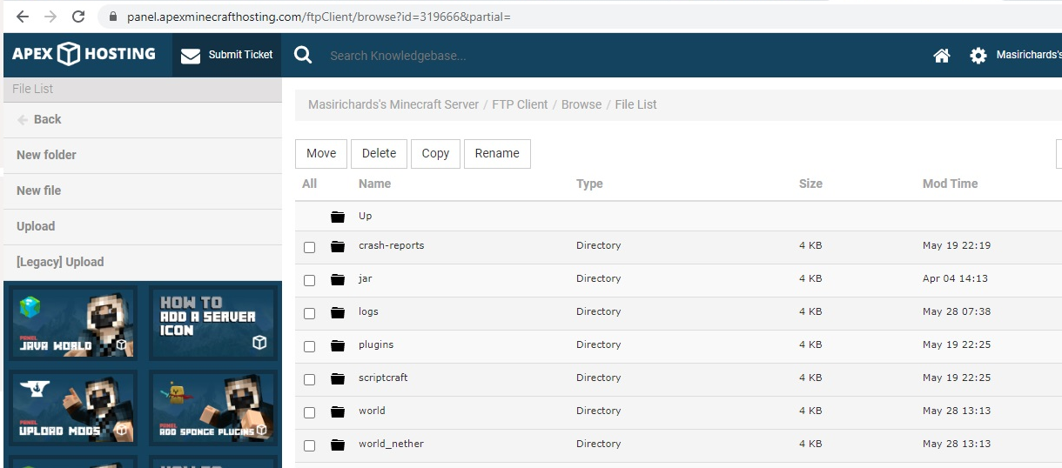  
Then use the console to restart the server

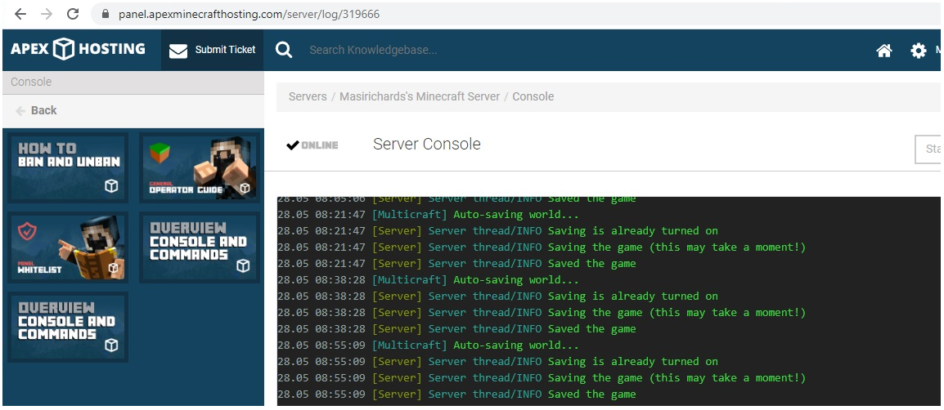

Project 2

Bedwars

Special Rules

When a player's team bed is destroyed they can no longer respawn

Protect from friendly damage

Only allow block destruction of beds and bed protection blocks

Game is over when only 1 team remains

Scaffold

A scaffold allows a player to walk "on air", because as they move a solid block is placed under their feet.

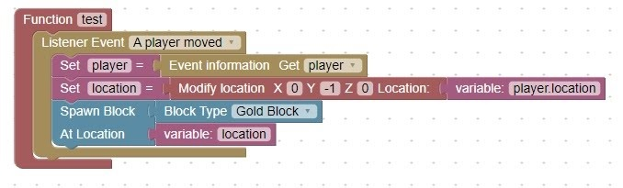

Respawn

A player can only respawn if their bed still exists.

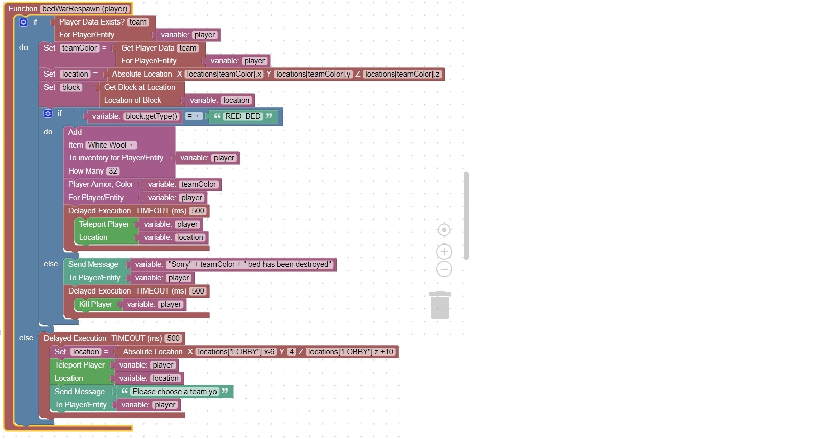

Bed Destruction

Notify all players when a bed is destroyed

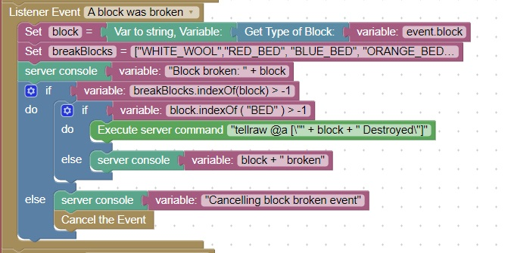

Splash Potion

A splash potion can create a special effect:

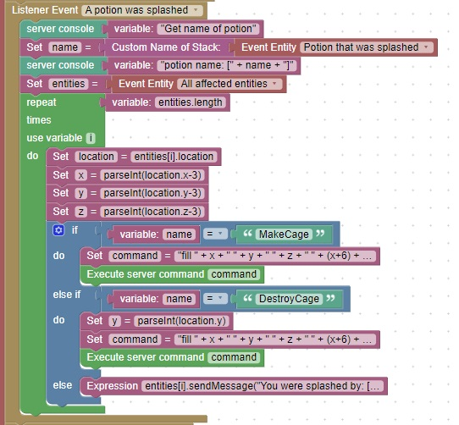

Game Over Detection

The game is over when only 1 team remains:

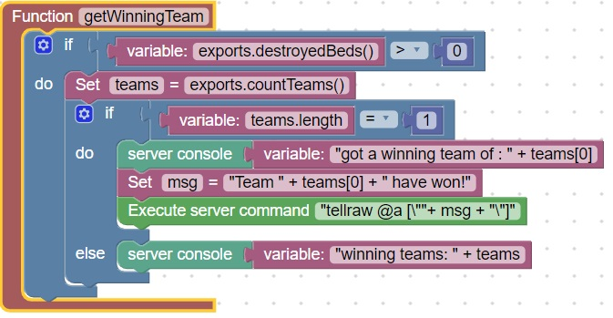

Project 3

Omaha Beach MiniGame

Highlights

Special Weapons

Managing multiple worlds and minigames

Special Weapons: Sniper arrows, Minigun

Special Player Types: King, Soldier

Protect player gear inventory after respawn

Public server configuration